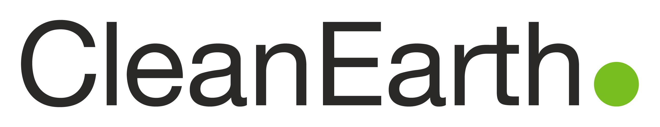 Date:
Vendor Payment Options &
Information Update Form

Initial Change

Clean Earth is committed to improving customer service to its vendors and improving the environment. We strive to make continuous sustainable improvements throughout our organization. We offer electronic payment options and electronic invoices/statements, account inquiries and changes can be sent by email to CE-Vendors@Harsco.com - reducing paper and improving efficiencies.

FAX
267-281-1332
Attn: AP Dept.
REGULAR MAIL Clean Earth, LLC
Attn: Accounts Payable
933 First Avenue, Suite 200
King of Prussia, PA 19406
E-MAIL RA_CEIUS_payables@harsco.com Subject line should read: Vendor Payment Form
(Attn: B. Pitts)

First, please help us to keep your information up to date:

Vendor Name:

Physical Address: City: State: Zip:

Payment Address:
City:
State:
Zip:

Phone: Fax:

A/R Dept. Phone: Ext #: A/R Contact Name:

A/R Email Address: Website Address:

Payment Options:

ACH (preferred payment method):
Yes NO
If yes, please provide the following details:

Bank Name: Name on Account:

Bank Account #:
ABA (Routing #):

MASTER CARD
Fee:
Yes No
AMEX
Fee:
Yes No

Your A/R Dept. email address to send MUST BE FILLED IN
ACH Remit Advice / Credit Card Authorization Form to:

Questions? 215.734.1400

